**Uploading Apache Logs to CloudWatch**

* Create an ec2 instance with Amazon linux
* Ensure IAM role is given to ec2 instance post launch
* Now login into the ec2 instance and install apache server

sudo yum install httpd -y

sudo systemctl enable httpd

sudo systemctl start httpd

* The path for the apache logs are /var/log/httpd/access_log and /var/log/httpd/error_log
* Now lets install cloudwatch agent

sudo yum install amazon-cloudwatch-agent -y

* Now configure cloudwatch agent

sudo /opt/aws/amazon-cloudwatch-agent/bin/amazon-cloudwatch-agent-config-wizard

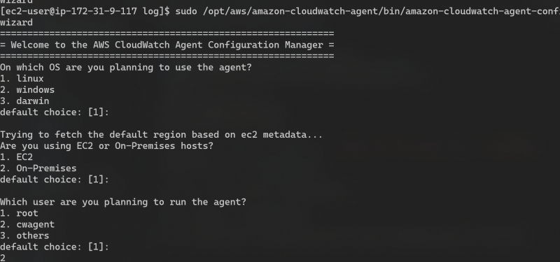  
* Continue with settings till you reach the log files section. configure for access logs  
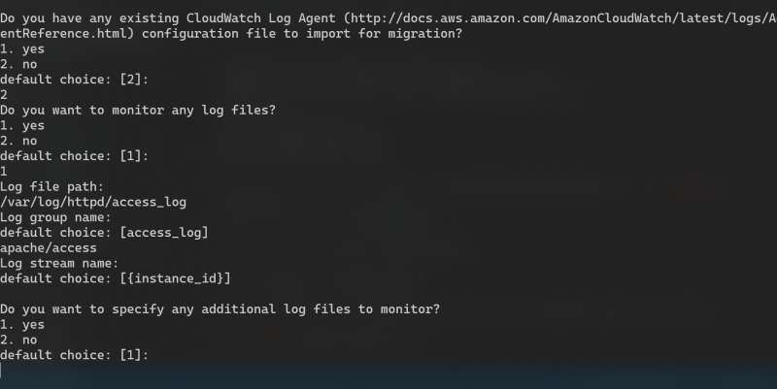  
* Now configure for error logs  
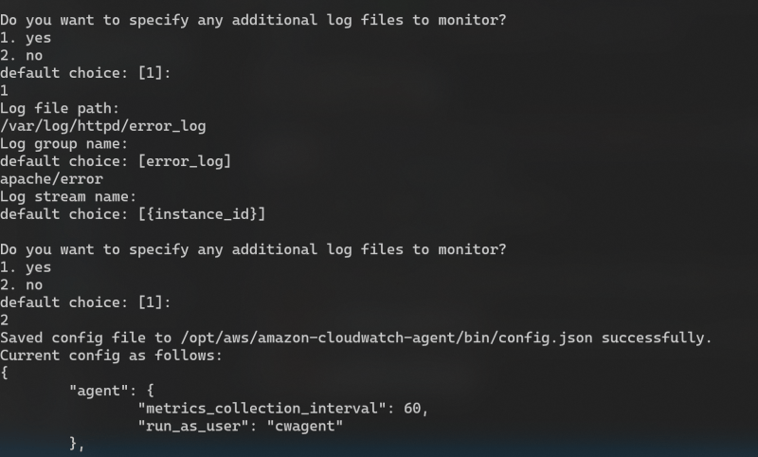  
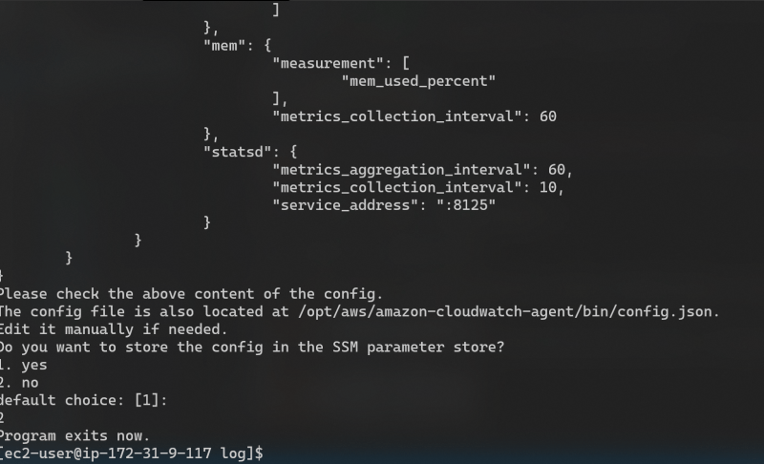  
* Now we need to inform the cloudwatch agent whihc configuration to use  
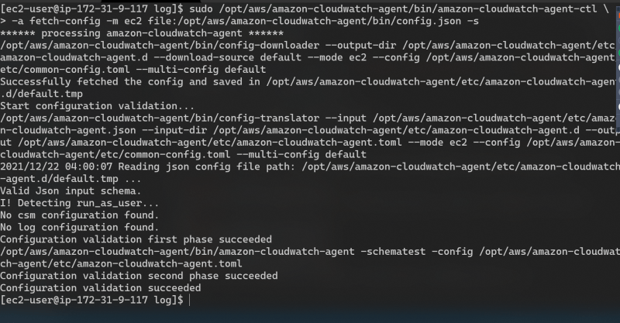

sudo /opt/aws/amazon-cloudwatch-agent/bin/amazon-cloudwatch-agent-ctl -a fetch-config -m ec2 -c file:/opt/aws/amazon-cloudwatch-agent/bin/config.json

* Now enable and start the cloudwatch agent

sudo systemctl enable amazon-cloudwatch-agent.service

sudo systemctl start amazon-cloudwatch-agent.service

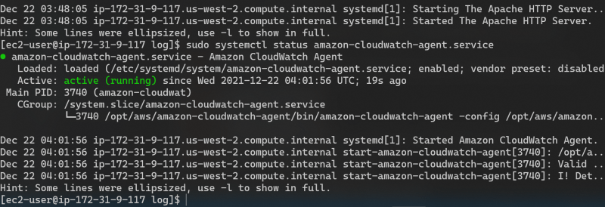  
* Sample script to generate traffic

#!/bin/bash

apache_url='http://18.237.201.9/'

while true

do

curl ${apache_url}

sleep 5

done